OSDS Trial Sanctioning

Application Form

Definition: A SANCTIONED TRIAL is an event which is organized by an OSDS member that follows OSDS requirements.

**Requirements for Trial Sanctioning:**

**1. The trial must be open to all OSDS members on an equal opportunity basis (note that it is not mandatory to offer all classes).**

**2. Entry forms must be published by OSDS on the website 30 days prior.**

**3. The opening date for entries and the closing date should be clearly listed.**

**4. Follow OSDS class definitions. If you plan to run to a standard this should also be stated on the entry form.**

**5. Follow ISDS or USBCHA rule book.**

**6. Results must be sent to point secretary within 14 days after trial.**

**7. Clearly state on the entry form that the trial is ‘OSDS Sanctioned’.**

**8. Points year runs from August 1 through July 31.**

**9. OSDS suggests each trial keep the original scoresheets signed by the judge for one year in case there is a question about scoring.**

Name of Trial_ _ _ Date(s) of Trial_ _ Location of Trial_ _ _

Classes Eligible for Points:

Sheep-

Novice-Novice Cattle-

Pro-Novice (Open Ranch)

Open

Started

Open

**Number of separate runs to count for points_**

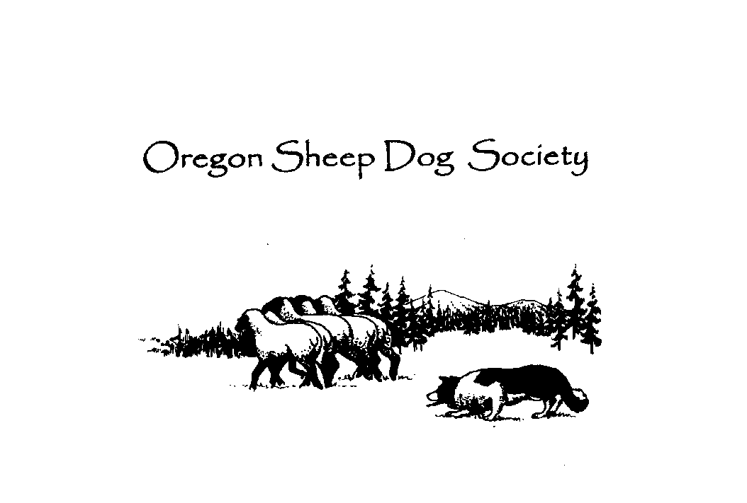

Trial Contact Person _

Phone_ _ E-Mail _

Before your trial, please complete and e-mail or send this form to OSDS with your trial entry forms:

Laurene Stepan - 7413 N.E.169th Street, Vancouver, WA 98684

Stepansquad@msn.com